Department of Computing

CS 366: Data Visualization
Class: BSCS – 13

Lab 3: Introduction to Pandas for Data Visualization
NAME: Muhammad Haadhee Sheeraz Mian
REG No: 478359

Date: 23 September 2025
Time: 10:00 AM– 1:00 PM

Instructor: Dr. Gibrail
Lab Engineer: Miss Ayesha Naeem
Lab 3: Introduction to Pandas for Data Visualization
TASK A:
1. Create a Series of game genres: 'Action', 'RPG', 'Sports', 'Adventure'
2. Create a DataFrame with columns: 'Game', 'Platform', 'Rating'
3. Add 3-4 rows of sample game data
4. Print both objects and their types
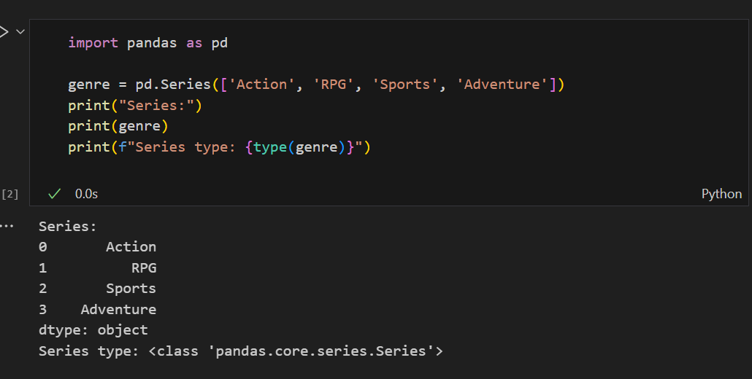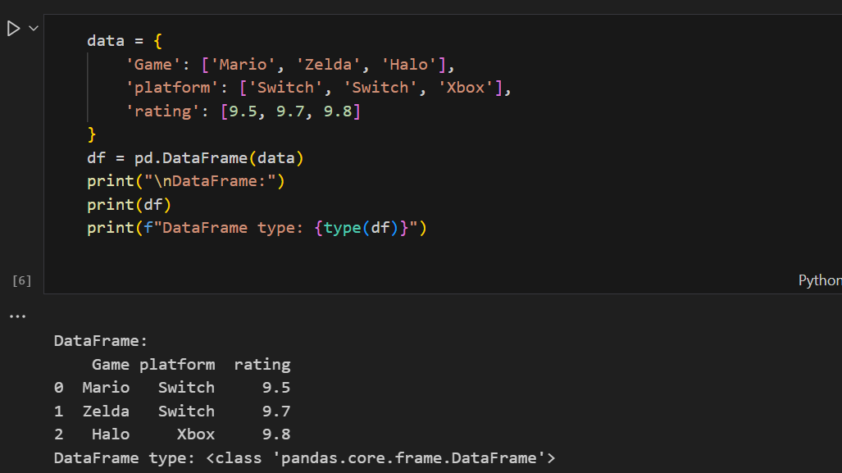

1.2: Loading and Initial Data Inspection
Definitions:
- CSV File: Comma-Separated Values file format
- DataFrame Attributes: Properties that describe the structure of the data
Example: Loading and Exploring Data
1.Load a CSV file
sample_data = pd.read_csv('sample_data.csv')

2. Basic DataFrame properties
print("DataFrame Shape:", sample_data.shape)
print("\nColumn Names:", sample_data.columns.tolist())
print("\nData Types:\n", sample_data.dtypes)

3.First few rows
print("\nFirst 5 rows:")
print(sample_data.head())

4.Basic information
print("\nDataFrame Info:")
sample_data.info()
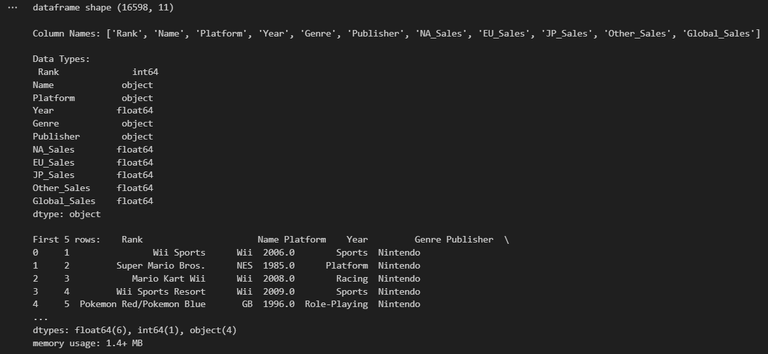
TASK B: Load and Explore Video Game Data
1. Load 'vgsales.csv' into a DataFrame called games_df
2. Print the shape and column names
3. Display the first 8 rows
4. Show the data types of all columns
5. Use .info() to get comprehensive information
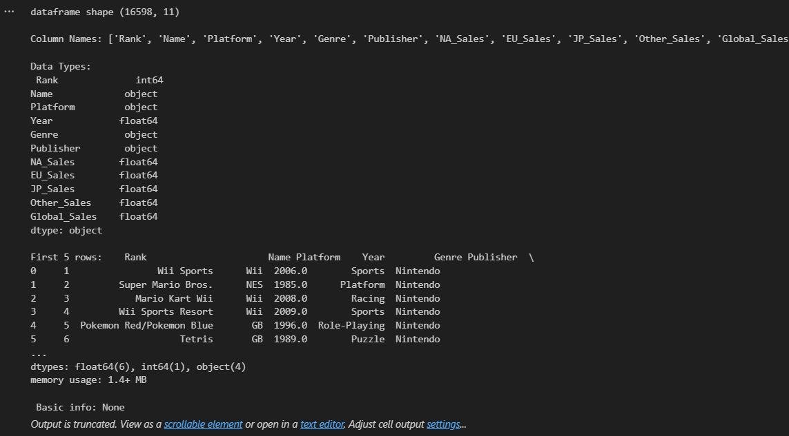

1.3: Basic Data Cleaning & Series Operations
Definitions:
- Missing Values: Empty or null entries in the dataset
- Series Operations: Mathematical and statistical operations on one-dimensional data
Steps to Perform:
Example: Series Operations and Cleaning
1.Working with Series
sales_series = sample_data['Sales']
print("Sales Series:")
print(sales_series.head())

2.Series operations
print("\nBasic Statistics:")
print("Mean:", sales_series.mean())
print("Max:", sales_series.max())
print("Min:", sales_series.min())

3.Handling missing values
print("\nMissing values before:", sample_data['column'].isnull().sum())
clean_data = sample_data.dropna(subset=['column'])
print("Missing values after:", clean_data['column'].isnull().sum())

4.Creating new Series
clean_data['new_series'] = clean_data['column']
print("\nNew Series:")
print(clean_data['new_series'].head())

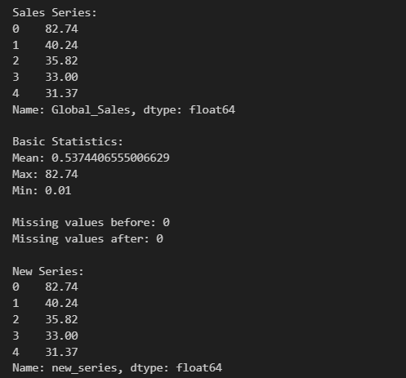

TASK C: Clean and Explore Game Data
1. Check for missing values in all columns
2. Remove rows where Year is missing
3. Calculate basic statistics for NA_Sales Series
4. Find the maximum value in EU_Sales Series
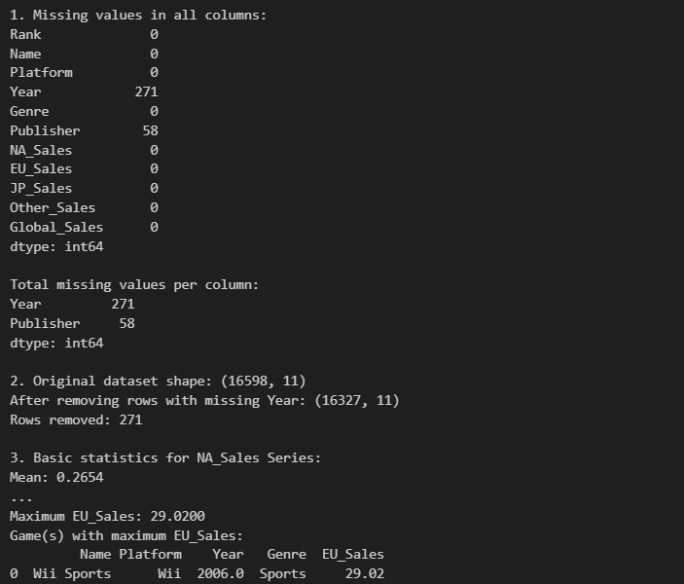 DataFrame Operations & Basic Visualization
2.1: DataFrame Selection and Filtering
Definitions:
- Data Selection: Extracting specific portions of a DataFrame
- Boolean Filtering: Selecting data based on logical conditions

Example: Selecting and Filtering Data
1.Selecting columns
platform_col = sample_data['Platform']
print("Platform Column:")
print(platform_col.head())

2. Selecting multiple columns
subset = sample_data[['Game', 'Platform', 'Year']]
print("\nMultiple Columns:")
print(subset.head())

3. Filtering rows
recent_games = sample_data[sample_data['Year'] > 2015]
print("\nGames after 2015:")
print(recent_games.head())

4. Multiple conditions
action_ps4 = sample_data[(sample_data['Genre'] == 'Action') &
(sample_data['Platform'] == 'PS4')]
print("\nAction games on PS4:")
print(action_ps4.head())
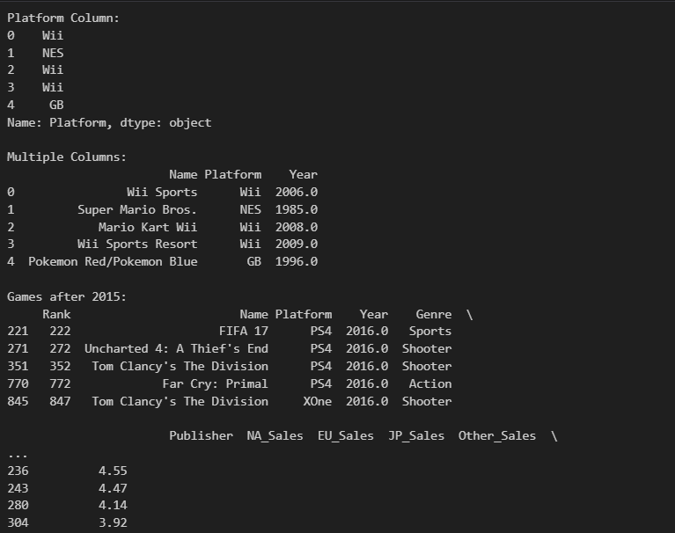
TASK D: Practice Selection and Filtering
1. Select only the 'Name' and 'Platform' columns
2. Filter games released after 2010
3. Find all RPG games on Nintendo platforms
4. Select games with Global_Sales greater than 5 million
5. Create a subset with only numerical columns
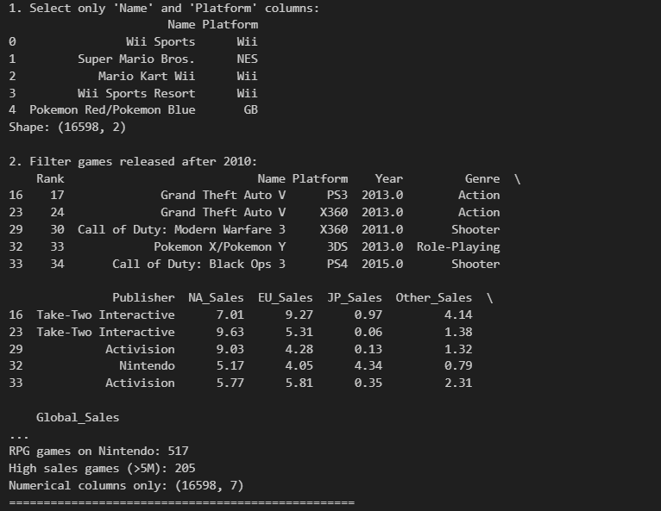
2.2: Basic Visualization with Series Data
Definitions:
- Data Visualization: Graphical representation of data and information
- Plot Types: Different ways to visualize data (line, bar, histogram, etc.)
Example: Creating Simple Visualizations
import matplotlib.pyplot as plt

1. Basic line plot from Series
yearly_sales = sample_data.groupby('Year')['Sales'].sum()
plt.figure(figsize=(10, 4))
yearly_sales.plot(kind='line', title='Sales Over Time')
plt.ylabel('Total Sales')
plt.show()

2. Histogram of sales distribution
plt.figure(figsize=(10, 4))
sample_data['Sales'].hist(bins=30)
plt.title('Sales Distribution')
plt.xlabel('Sales')
plt.ylabel('Frequency')
plt.show()
TASK E: Create Basic Visualizations
1. Create a line plot of games released per year
2. Make a suitable chart of top 10 game genres
3. Create a histogram of Global_Sales distribution
4. Make a pie chart of regional sales percentages
5. Create a box plot of sales by platform for top 5 platforms
1. Line plot of games released per year:
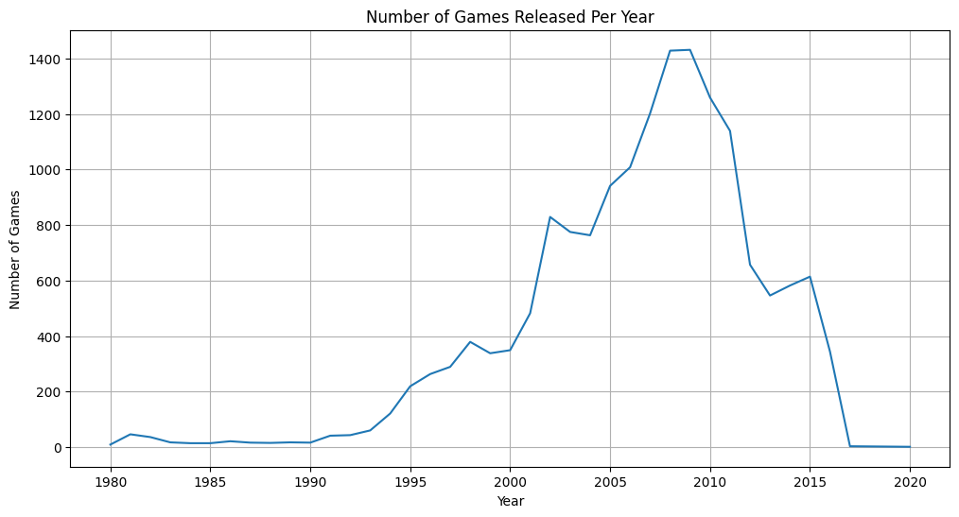 2. Bar chart of top 10 game genres:
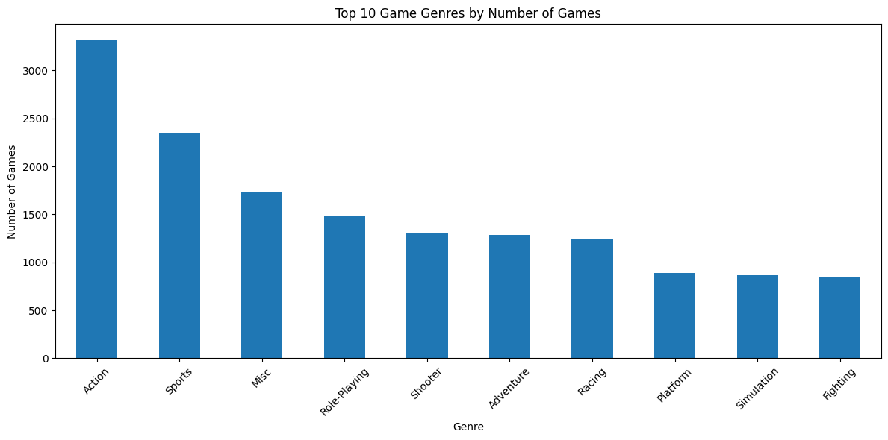
3. Histogram of Global_Sales distribution:
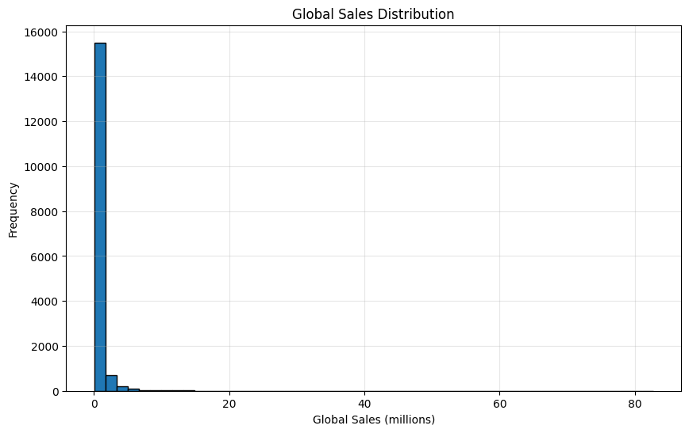
4. Pie chart of regional sales percentages:
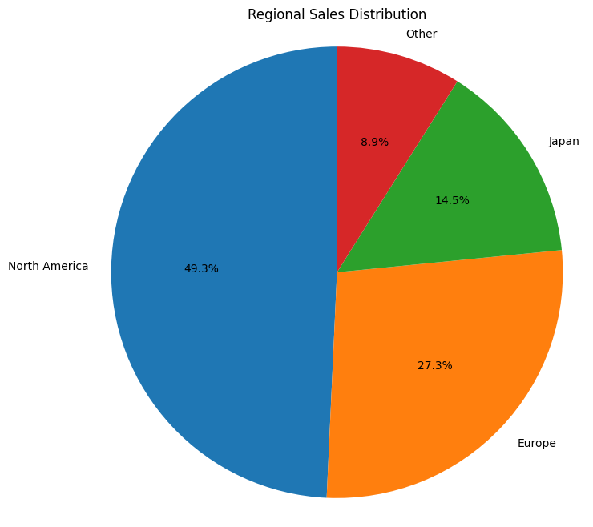
5. Box plot of sales by platform for top 5 platforms:
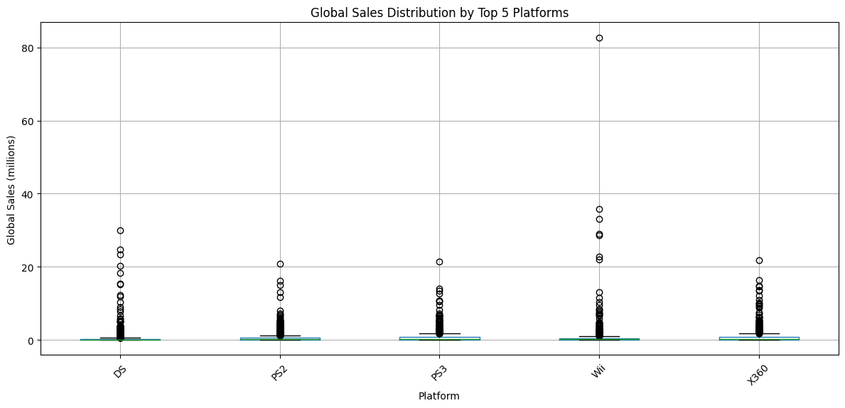
Advanced Operations & Comprehensive Analysis
3.1: Grouping and Aggregation
Definitions:
- GroupBy Operations: Splitting data into groups based on criteria
- Aggregation: Computing summary statistics for each group
GroupBy Operations

1.Basic grouping
genre_group = sample_data.groupby('Genre')
print("Number of groups:", genre_group.ngroups)

2.Aggregation methods
genre_stats = genre_group['Sales'].agg(['mean', 'sum', 'count'])
print("\nGenre Statistics:")
print(genre_stats.head())

3.Multiple aggregations
platform_stats = sample_data.groupby('Platform').agg({
'Sales': ['mean', 'sum', 'max'],
'Year': ['min', 'max']
})
print("\nPlatform Statistics:")
print(platform_stats.head())

4.Group by multiple columns
genre_platform = sample_data.groupby(['Genre', 'Platform'])['Sales'].mean()
print("\nSales by Genre and Platform:")
print(genre_platform.head())
TASK F: Practice Grouping Operations
1. Group by Platform and calculate mean Global_Sales
2. Group by Genre and find total sales for each genre
3. Group by Year and count number of games
4. Group by Platform and Genre, calculate mean sales
5. Find the publisher with the highest average sales
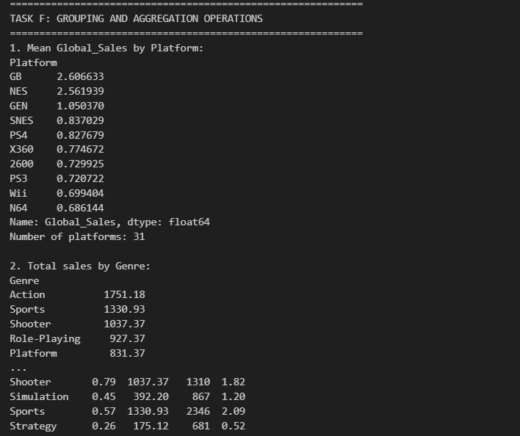
3.2: Data Transformation and New Features
Definitions:
- Data Transformation: Changing the structure or values of data
- Feature Engineering: Creating new variables from existing data
Steps to Perform:
- Create categorical variables from numerical data
- Perform string operations on text data
- Create new time-based features
- Apply custom functions to transform data
Example: Data Transformation
1. Creating new columns
sample_data['Sales_Category'] = pd.cut(sample_data['Sales'],
bins=[0, 1, 5, 10, 100],
labels=['Low', 'Medium', 'High', 'Very High'])
print("Sales Categories:")
print(sample_data['Sales_Category'].value_counts())

2. String operations on Series
df['Upper'] = df['column_name'].str.upper()
print("\nUppercase :")
print(df[['column_name', 'Upper']].head())

3. DateTime operations (if Year were datetime)
df['Decade'] = (df['Column_name'] // 10) * 10
print("\nDecade Distribution:")
print(df['Decade'].value_counts().sort_index())

4. Applying functions to Series
def sales_category(column_name):
if sales > 10:
return 'Blockbuster'
elif sales > 1:
return 'Hit'
else:
return 'Regular'

df['Sales_Type'] = df['column_name'].apply(function_name)
print("\nSales Types:")
print(df['Sales_Type'].value_counts())
TASK G: Transform and Enhance Data
1. Create a decade column from Year
2. Categorize Global_Sales into Low/Medium/High
3. Convert all game names to uppercase
4. Create a new column for total regional sales
5. Apply a function to categorize games by sales performance
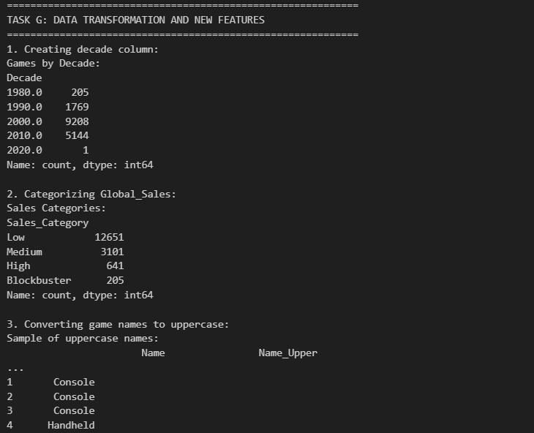
3.3: Comprehensive Analysis Project
Definitions:
- Exploratory Data Analysis: Analyzing data sets to summarize their main characteristics
- Data Storytelling: Communicating insights through data visualization and narrative
Steps to Perform:
- Perform comprehensive data analysis
- Create multiple visualizations
- Generate insights from the data
- Present findings in a clear manner
TASK G: Complete Video Game Analysis
Create a comprehensive analysis that includes:
- Basic dataset information
- Top 10 best-selling games
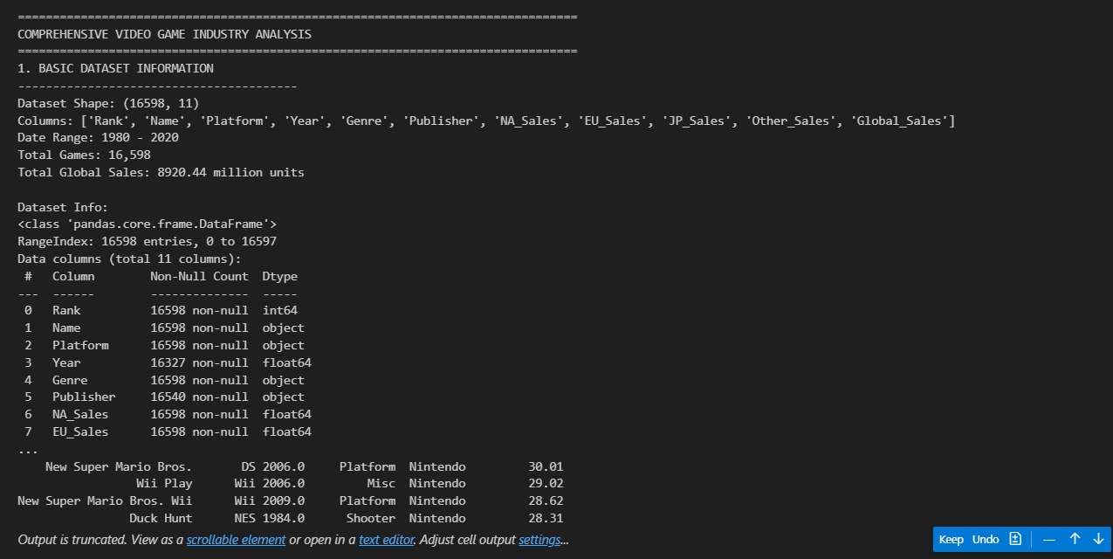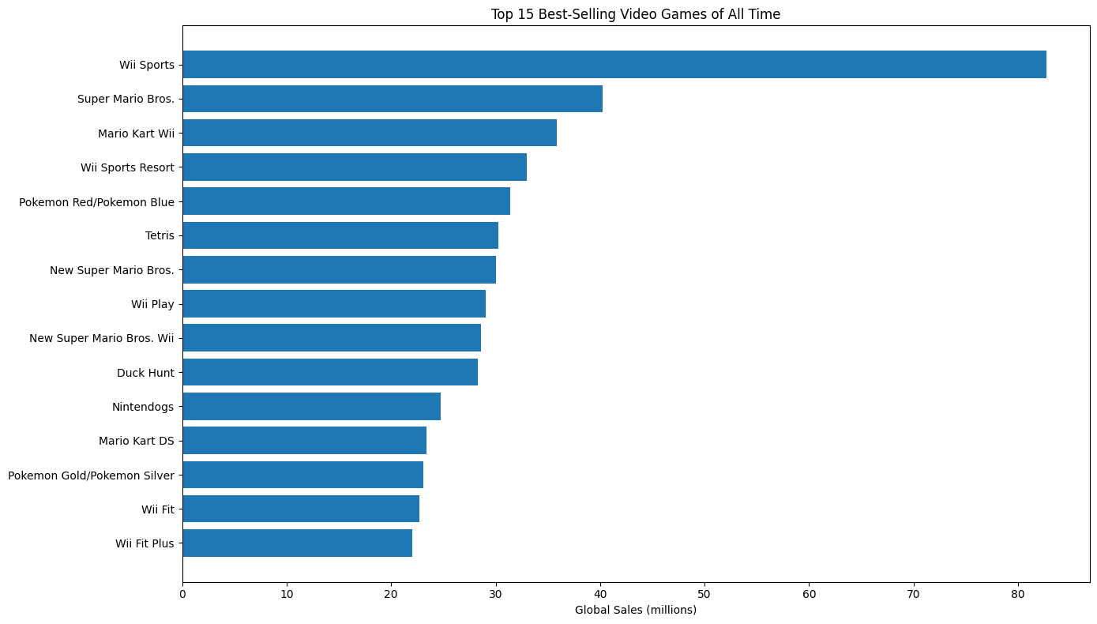

3. Sales analysis by platform
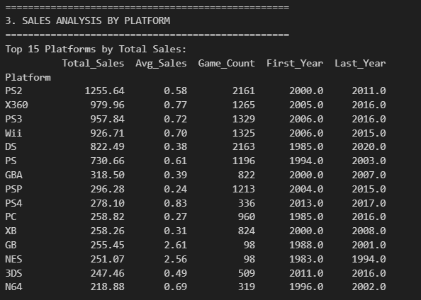
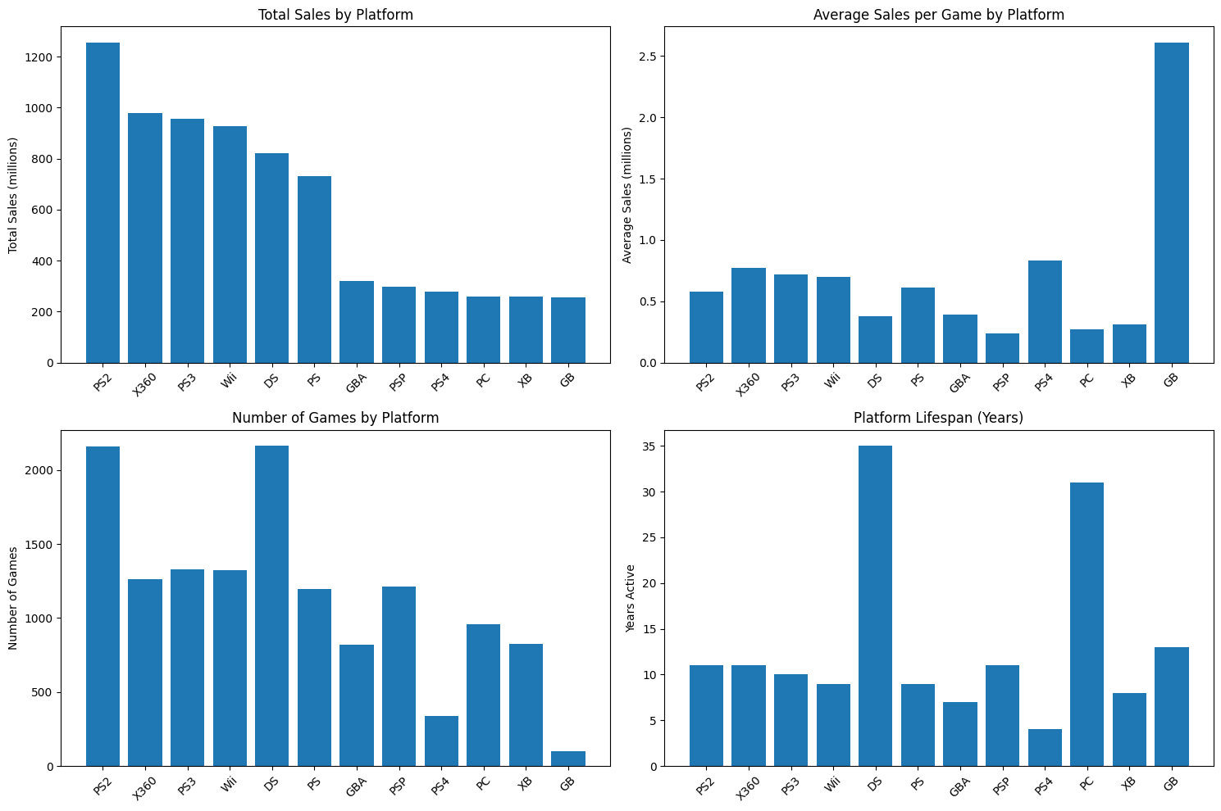
4. Genre popularity over time
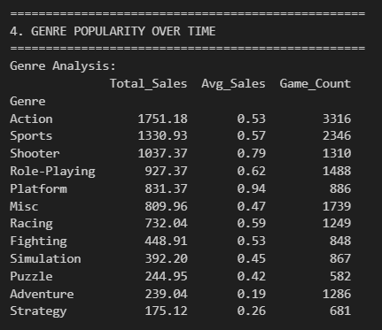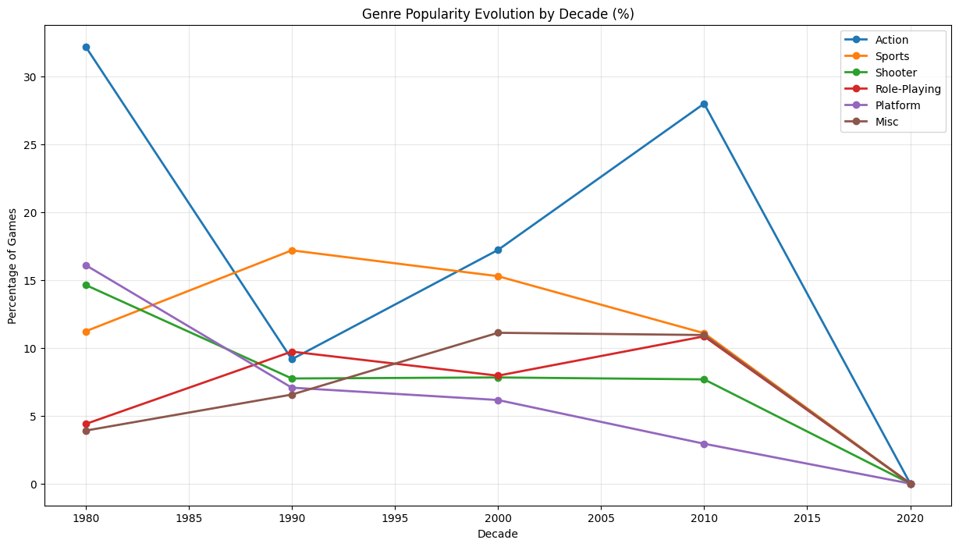
5. Regional sales comparison
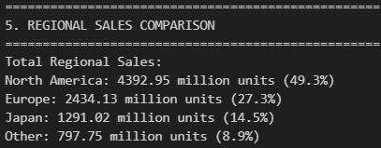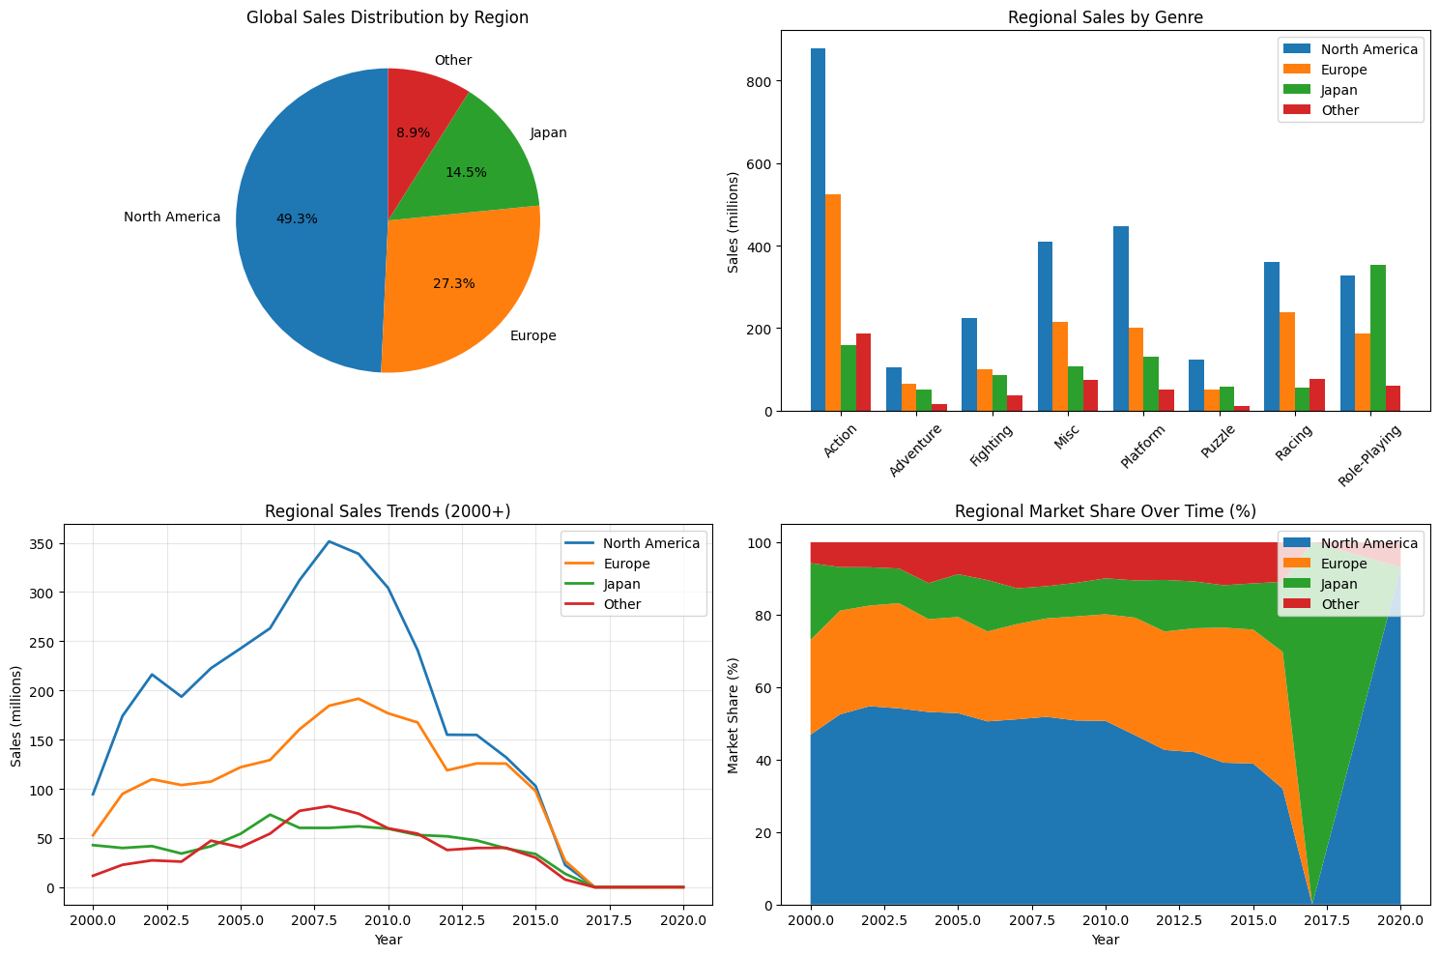

3.4: Insights & Reflection
Critical Thinking Questions:
1. What are the main advantages of using pandas Series over regular Python lists?
Pandas Series advantages:
- Vectorized Operations: Can perform mathematical operations on entire Series at once (sales_series.mean(), sales_series.sum())
- Built-in Statistical Methods: Direct access to .mean(), .std(), .max(), .min(), .describe()
- Index Labels: Each element has both position and label-based access
- Data Type Consistency: Ensures homogeneous data types with automatic type inference
- Missing Value Handling: Built-in methods like .isnull(), .dropna(), .fillna()
- Memory Efficiency: More memory-efficient than Python lists for large datasets
- Integration with DataFrames: Seamless operations with DataFrame columns
Example from our analysis:
# Series operation (simple)
na_sales_series.mean() # Instant statistical calculation

# vs Python list (complex)
sum(python_list) / len(python_list) # Manual calculation needed

2. How does DataFrame filtering differ from Series operations?
DataFrame Filtering:
- Multi-dimensional: Can filter on multiple columns simultaneously
- Complex Conditions: Support for & (and), | (or) operations
- Column Selection: Can select specific columns after filtering
- Preserves Structure: Maintains row-column relationship
Series Operations:
- Single-dimensional: Operations on one column/vector at a time
- Element-wise: Each operation applies to individual elements
- Simpler Syntax: Direct comparison operations
Examples from our analysis:
# DataFrame filtering (complex)
action_ps4 = game_df[(game_df['Genre'] == 'Action') & (game_df['Platform'] == 'PS4')]

# Series operation (simple)
high_sales = game_df['Global_Sales'] > 5.0

3. Which grouping operation was most useful for understanding the data?
Most useful: Multi-level grouping with aggregation
The Platform and Genre grouping was most insightful:
platform_genre_sales = game_df.groupby(['Platform', 'Genre'])['Global_Sales'].mean()

Why it was most useful:
- Market Segmentation: Revealed which game types perform best on specific platforms
- Business Insights: Showed platform-specific preferences (e.g., RPGs on Nintendo, Action on PlayStation)
- Strategic Planning: Helps developers choose optimal platform-genre combinations
- Competitive Analysis: Identified market gaps and opportunities
Other valuable groupings:
- Publisher analysis: Identified most successful publishers
- Yearly trends: Showed industry growth patterns
- Regional preferences: Revealed geographic market differences
4. What challenges did you face when creating visualizations?
Technical Challenges:
- Subplot Layout: Managing multiple plots in plt.subplot(2,2,x) required careful spacing with plt.tight_layout()
- Label Rotation: Platform names overlapping, solved with plt.xticks(rotation=45)
- Legend Positioning: Managing legend placement with bbox_to_anchor=(1.05,1)
- Data Preprocessing: Filtering top N items for cleaner visualizations
Data Challenges:
- Scale Differences: Sales values varied dramatically (0.01 to 82+ million)
- Categorical Overload: Too many genres/platforms made charts cluttered
- Missing Values: Had to handle NaN values before plotting
- Outliers: Extreme values skewed distribution plots
Design Challenges:
- Color Schemes: Choosing distinguishable colors for multiple categories
- Chart Type Selection: Deciding between bar, line, pie charts for different data types
- Information Density: Balancing detail vs. Readability
- # Filtering for cleaner plots
- top_platforms = game_df['Platform'].value_counts().head(5).index

- # Better spacing
- plt.tight_layout()

- # Removing outliers for better visualization
- df = df[df["Sales"] <= 10000]

5. How might you use these skills in a real-world data analysis project?
Business Applications:
1. Market Research & Strategy:
- Customer Segmentation: Group customers by demographics, purchase behavior
- Product Performance: Analyze sales by region, time, product category
- Competitor Analysis: Compare market share, pricing strategies
2. Financial Analysis:
- Revenue Forecasting: Time series analysis of sales trends
- Risk Assessment: Identify patterns in financial losses/gains
- Budget Planning: Analyze spending patterns across departments
3. Healthcare & Research:
- Patient Data Analysis: Group by symptoms, treatments, outcomes
- Clinical Trials: Statistical analysis of treatment effectiveness
- Epidemiological Studies: Track disease patterns across demographics
4. E-commerce & Retail:
- Inventory Management: Predict demand patterns by season, location
- Recommendation Systems: Analyze user preferences and behaviors
- Price Optimization: A/B testing for optimal pricing strategies
- # Real-world example: E-commerce analysis
- # Group customers by region and calculate average order value
- customer_analysis = df.groupby(['Region', 'Customer_Type']).agg({
- 'Order_Value': ['mean', 'sum', 'count'],
- 'Purchase_Date': ['min', 'max']
- })

- # Visualize seasonal trends
- monthly_sales = df.groupby('Month')['Revenue'].sum()
- plt.figure(figsize=(12,6))
- monthly_sales.plot(kind='line')
- plt.title('Monthly Revenue Trends')

